Claim Setup Rules Solution

Exercise 1: Investigation

Answer the following questions about the segmentation rules in the sample data.

1. A property exposure is set to "prop_low" under what conditions?  
     
   The exposure type is personal property damage or property damage, AND the incident's severity is minor.
2. What segment is a property exposure assigned to if the conditions for the Property Low, Property Medium, and Property High rules are all false?  
     
   prop_mid, which is accomplished in the Property Default rule.

Answer the following question about the workplan rules in the sample data.

1. In the Claim Workplan rule set, every time the createActivityFromPattern method is called, the first argument is null. Why?  
     
   The claim workplan rules create claim-level activities. The first argument is used to specify the related exposure. Since there is no related exposure, the argument is null.
2. Most exposure types referenced in the sample rules cause only a single activity to be created. Which exposure type can cause two activities to be created?   
     
   Bodily Injury Damage

Exercise 2: Configuration

Configure ClaimCenter to meet the following customer requirement from Acme Insurance.

Requirement: Segmentation for Property Claim Fraud Detection

Acme Insurance has experienced a rise of fraudulent property claims in which a loss occurred. For example, a new policy was issued and a loss was reported shortly after the policy came into effect. Acme wants to use claim segmentation to help identify claims which are possibly fraudulent in this way.

1. Modify the Claim Segment typelist by adding a typecode that has the name "Early Term Loss”, which will be visible in the UI.
2. As this constitutes a change to the data model, you need to restart the application server and regenerate your data dictionary.

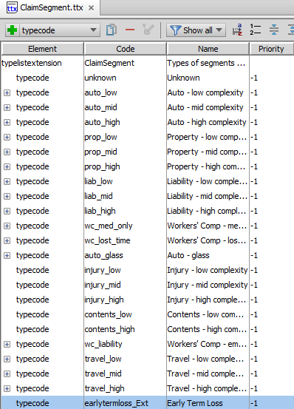

1. Modify the claim segmentation rules such that if a property claim has a loss date which is within 30 days of the policy's effective date, the claim is segmented as an "Early Term Loss". This takes precedence over all other property segmentation rules. Give the rule a name that is descriptive of its purpose and conforms to best practices for naming rule sets.
2. For the segmentation rule, you need to use a date library function.
3. If this segmentation rule segments the claim, then you should exit the rule set.

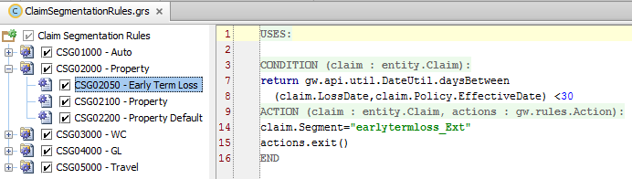

1. Modify the claim workplan rules such that claims segmented as "Early Term Loss" will have two activities created:

* “Get the property inspected” activity (code: property_inspection)
* “Make a diary entry in 90 days” activity  (code: 90_day_diary)

Your solution should avoid creating duplicates of either of these activities. HINT: Check to see if any existing rules create these activities.

